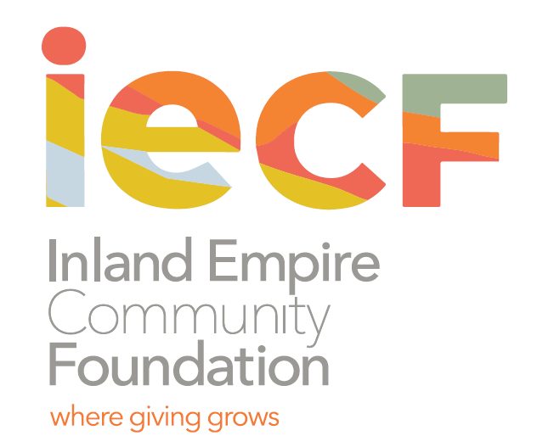

Contact: Charee Gillins FOR IMMEDIATE RELEASE

951.241.7777 February ?, 2021

cgillins@iegives.org

www.iegives.org

**Youth Grantmakers are Accepting Proposals from Nonprofits Supporting**

**Youth in Coachella Valley**

Riverside, CA – Are you a nonprofit serving youth through unique projects and programs? The Youth Grantmakers of the Inland Empire Community Foundation might help fund it.

The Inland Empire Community Foundation serving Riverside and San Bernardino Counties is now accepting applications for grants from the Coachella Valley Youth Grantmakers Fund through March 5, 2021.

The Coachella Valley Youth Grantmakers provides grants to nonprofits in the Coachella Valley for programs, projects and activities that support the well-being of youth and teens in the desert. This year’s class consists of high school students from Rancho Mirage High School, Xavier College Prep High School, Cathedral City High School, Shadow Hills High School, La Quinta High School, Palm Springs High School and Palm Desert High School who review grant proposals, conduct nonprofit site visits and recommend grants for funding.

Started in 2009, the program was created to empower youth to address issues important to them by learning about and leading the grantmaking process. Not only do these young people become civically engaged, but better prepared for community leadership and more aware of the nonprofit sector.

“We encourage nonprofits in the Coachella Valley that support the well-being of the youth and teens in the desert to apply for this great opportunity,” said Adrian Marquez, a participant of the Coachella Valley Youth Grantmakers.

To view grant guidelines, determine eligibility, and download a grant application, please visit the [Grant Guidelines](https://www.iegives.org/wp-content/uploads/2021/02/2021-YG-Coachella-Guidelines-Appl.pdf). For assistance, contact Denisha Shackelford, Youth Initiatives Manager, at 951.241.7777 or at dshackelford@iegives.org.

*About the Inland Empire Community Foundation (formerly The Community Foundation)*

*Founded in 1941, the Inland Empire Community Foundation is the oldest and largest community foundation in Inland Southern California. We partner with individuals, families and corporations to help them achieve their charitable goals. Since inception, we have given out over $100 million in grants and scholarships. For more information visit the IECF’s website at* [*www.iegives.org*](http://www.iegives.org/)*. Be a part of our conversation on Facebook, Twitter and LinkedIn.*

###