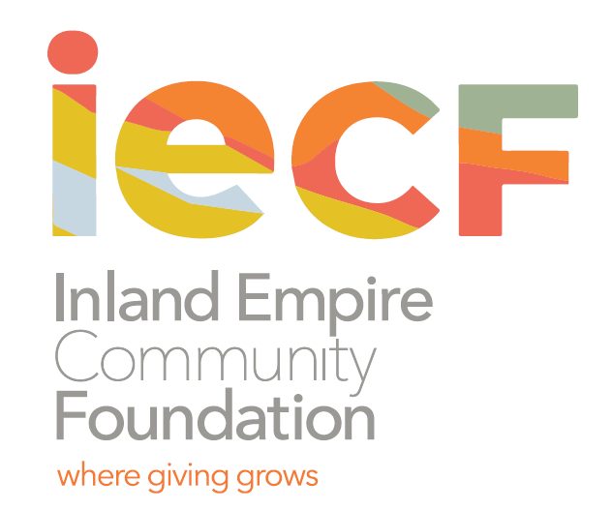

Contacts: Charee Gillins, IECF FOR IMMEDIATE RELEASE

951.255.4254 March 11, 2021

[cgillins@iegives.org](mailto:cgillins@iegives.org)

Jennifer Kane, Arts Connection

909.381.1900

[jennifer@artsconnectionnetwork.org](mailto:jennifer@artsconnectionnetwork.org)

Contact: Felicia Jones, C.O.P.E

323.788.5581

[fjones@copesite.org](mailto:fjones@copesite.org)

**The James Irvine Foundation Invests $2.7 Million in the First Phase of Just San Bernardino Collaborative Project**

*10,000+ residents of the City of San Bernardino to engage in a landmark, multiyear economic development project.*

SAN BERNARDINO, CA - The Just San Bernardino Collaborative (Just SB) announced today the launch of a People’s Plan for Economic Inclusion with a generous $2.7 million project grant from The James Irvine Foundation, and support from its community partner, the Inland Empire Community Foundation.

Set to engage over 10,000 residents in San Bernardino over the next year, the People’s Plan and the strategies used to develop it will address the lack of economic growth of low-income communities through the lens of labor, housing, education, environmental justice, economic development, arts/culture, and healthcare. It is a grassroots driven process that focuses on community-centered approaches, even during socially distanced times. Some of these approaches will include an upcoming survey, community listening sessions, and other creative events.

Under the leadership and expertise of nine community-based organizations in the Inland Empire, the People’s Plan specifically mobilizes power-building around economic development in the City of San Bernardino. Called “Just SB,” the group chose this title to clearly focus the efforts on centering justice for future economic development in the city.  These collaborating organizations represents a broad spectrum of industries and includes: Time for Change Foundation, BLU Educational Foundation, Youth Action Project (YAP), Arts Connection, Inland Empire Labor Council, Warehouse Workers Resource Center, Inland Congregations United for Change (ICUC), Congregations Organized for Prophetic Engagement (C.O.P.E), and the People’s Collective for Environmental Justice (PCEJ).

“I am extremely proud to be intimately associated with the work of the JUST SB People’s Plan. I firmly believe that those closest to the conditions that they find themselves in, are best equipped to inform this process and path forward,” shared Pastor Samuel Casey, Executive Director of C.O.PE. “By focusing our efforts on a participatory process involving community voices, we believe it will produce a true People’s Plan.”

Formed in late 2019 with the support of the Inland Empire Community Foundation (IECF) and The James Irvine Foundation, Just SB spent a year learning together and developing strategies in response to the historic and growing disparities in education, health, housing, and job opportunities and wage equity in the Inland Empire.

“Through the tragedy of COVID, we have learned so much more about what equity and justice should mean, and what is essential work and workers. The People’s Plan is an exciting and concrete way for the residents of San Bernardino to answer that question directly, for themselves,” said Michelle Decker, CEO of Inland Empire Community Foundation. “We are all learning that building an economy that closes economic, racial, and gender gaps will require truly inclusive conversations and leadership by those most affected, and we believe Just SB will help us all learn how to do that authentically.”

The Irvine Foundation investment in Just SB and the People’s Plan is aligned with their Priority Communities strategy to create and protect more good jobs that offer family-sustaining wages, benefits, and advancement opportunities for workers in low-wage jobs – and support communities as they create economies that work for all residents.

For more information about the survey launch (coming in early April) and Just SB’s work, visit www.justsb.org

###

**Just San Bernardino Collaborative: Partner Organizations**

*Art Connection’s* mission is to elevate arts and culture in San Bernardino County. Drawn by a vision to create a sustainable place for arts and culture in development so that each of our communities has equitable representation and resources, our work is rooted in the belief that access to cultural and arts experiences is a human right and a vital component to sustaining healthy, equitable, and vibrant places for each of our residents to thrive. Arts Connection is directed by Jennifer Kane, with operational support from Saniyyah Thomas and a regional Program Director, Marie Bobin, in the Morongo Basin.

*BLU Educational Foundation*’s mission is to provide educational and human services programming to youth, adults, and organizations in order to build healthy productive communities with initiatives that focus on education, health & wellness, civic engagement, leadership development, advocacy, and the Arts. BLU is led by Dina Walker, Founder and President.

*Congregations Organized for Prophetic Engagement (COPE*) is a 501(c)3 faith-based organization, established in 2000 by a core group of pastors with a mission to “train and develop the capacity of religious and lay leaders in congregations and across the Inland Empire to protect and revitalize the communities in which they live, work, and worship.” COPE achieves its mission through grassroots organizing to disrupt the structures that lead to a cycle of incarceration—education, health, housing, justice systems. COPE is governed by a 5-member board of directors and led by Pastor Samuel Casey, the founding Executive Director.

*Inland Congregations United for Change (ICUC)* is a faith-based 501(c)3 non-profit community organization serving San Bernardino and Riverside Counties. ICUC empowers people of faith to transform and revitalize the Inland Empire by working in the civic arena for the common good. ICUC assists communities of faith who desire to initiate or deepen social ministry within their congregation. Professional community organizers train congregation members in the principles of faith-based civic engagement and coach leaders through self-selected, relevant and practical community organization efforts. Through these efforts, individual participants develop public leadership skills and become catalysts of positive change within their congregations, neighborhoods and cities. ICUC is led by Tom Dolan, Executive Director.

*Inland Empire Labor Council* is one of nearly 500 state and local labor councils of the AFL-CIO that are democratically elected bodies dedicated to represent the interests of working people at the state and local level. The Inland Empire Labor Council mobilizes its members and community partners to advocate for social and economic justice and strive daily to vanquish oppression and make communities better for all people while paying specific attention to structural inequalities around issues of race, color, gender, religion, age, sexual orientation, and ethnic or national origin. IELC is helmed by Executive Secretary/Treasurer Ricardo Cisneros, Political Director Celene Perez, and Mike Chavez who directs its non-profit sector.

The mission of the *People’s Collective for Environmental Justice*, rooted in historical struggle, is to advance collective resistance, power and support to fight against pollution, exploitation and existential threats to life – building for the health, wellbeing and self-reliance of the Inland Empire that uproots white supremacy and the reigning hegemonic extractive systems. PCEJ’s team includes Jean Kayano, Brenda Huerta Soto, Hakan Jackson, Andres Garcia, Andrea Vidaurre, Graciela Mendez, Deyadira Arellano, and Anthony Victoria.

*Time for Change Foundation (TFCF)* has a mission to empower disenfranchised low-income individuals and families by building leadership through evidence-based programs and housing to create self-sufficiency and thriving communities. Our current capacity includes community development, economic development, and a social enterprise. Community Development - The Phoenix Square Affordable Housing. Economic Development - Positive Futures I Asset Development and Wealth Creation Project. Social Enterprise - Center for Advocacy and Leadership Training. TFCF was founded by Kim Carter and is currently led by Vanessa Perez, Executive Director.

*Warehouse Worker Resource Center* organizes workers and communities across the Inland Region to improve working conditions and standards in workplaces through education, advocacy and action. WWRC has brought workers together to move thousands of warehouse jobs from temporary to direct, full-time employment. WWRC is led by Sheheryar Kaoosji, Executive Director, and Veronica Alvarado, Deputy Director, who co-founded the organization in 2011.

*Youth Action Project’s (YAP)* mission is to empower youth and young adults in the development of the skills and habits needed to experience economic and social success. YAP focuses on positive youth development, academic support, and workplace readiness to ensure that all opportunity youth enrolled in YAP programs graduate from high school, transition to post-secondary education and enter meaningful and gainful employment or entrepreneurial ventures. YAP is led by Tremaine Mitchell, Executive Director.

Founded in 1941, *Inland Empire Community Foundation* is the oldest and largest community foundation in Inland Southern California. We partner with individuals, families and corporations to help them achieve their charitable goals. Since inception, we have given out over $100 million in grants and scholarships. For more information visit the IECF’s website at www.iegives.org. Be a part of our conversation on Facebook, Twitter and LinkedIn.